Stuxnet: A Case Study in Advanced Man-in-the-Middle Attacks on Industrial Control Systems

Team no. 5
Aaryan Sharma- 16010123012,
Aditey Kshirsagar - 16010123017,
Aditya Baheti- 16010123023,
Amandeep Singh Rathod - 16010123036,
Ambuj Rai - 16010123037

Executive Summary
The Stuxnet worm, discovered in June 2010, represents the first known cyberweapon designed to cause physical destruction through digital means. This sophisticated malware employed advanced man-in-the-middle (MITM) techniques to infiltrate and manipulate Iran's nuclear enrichment facilities at Natanz, demonstrating unprecedented capabilities in crossing the digital-physical divide. The attack's success stemmed from its ability to intercept communications between human operators and industrial control systems while presenting falsified data to mask its destructive activities.

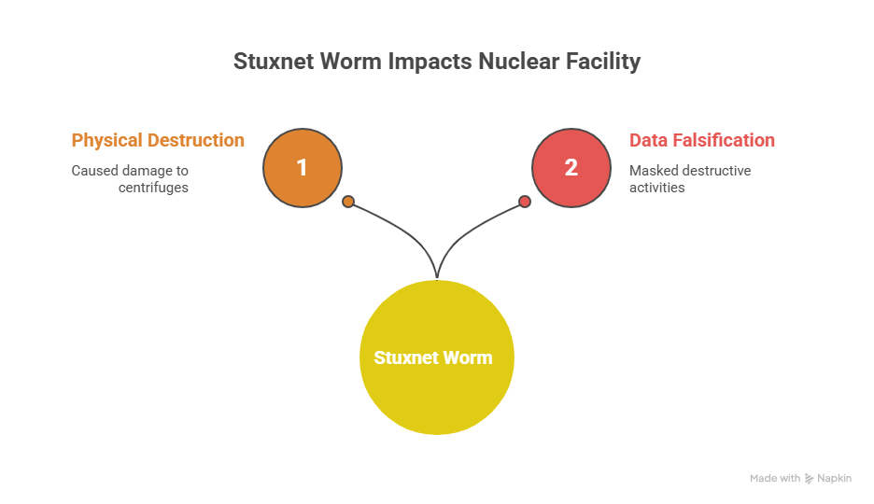

1. Timeline of Events
1.1 Development Phase (2007-2009)
- 2007: Initial development believed to begin as part of "Operation Olympic Games"
- January 2009: First component (mrxnet.sys) compiled
- June 2009: First wave of attacks targeting five Iranian organizations

1.2 Active Attack Period (2009-2010)
- Late 2007: Stuxnet believed to first infect Natanz systems
- 2009-2010: Approximately 1,000 IR-1 centrifuges decommissioned and replaced at Natanz
- June 23, 2010: Second wave begins with infection of Foolad Technic
- June 29, 2010: Behpajooh engineering firm infected

1.3 Discovery and Response (2010-2012)
- June 17, 2010: VirusBlokAda (Belarus) discovers Stuxnet
- July 16, 2010: Verisign revokes compromised Realtek certificate
- September 2010: Symantec and Kaspersky begin detailed analysis
- November 2010: Iranian President Ahmadinejad acknowledges attack impact
- June 24, 2012: Stuxnet programmed self-termination date

1.4 Key Actor Roles
Attackers: Believed to be joint U.S.-Israeli intelligence operation
- Technical Capability: Nation-state level resources and expertise
- Access Method: Supply chain compromise through Iranian nuclear contractors
- Delivery Vector: USB drives inserted by unwitting insiders

Victims: Iranian nuclear program and global industrial infrastructure
- Primary Target: Natanz Fuel Enrichment Plant (FEP)
- Secondary Impact: 200,000+ computers worldwide infected

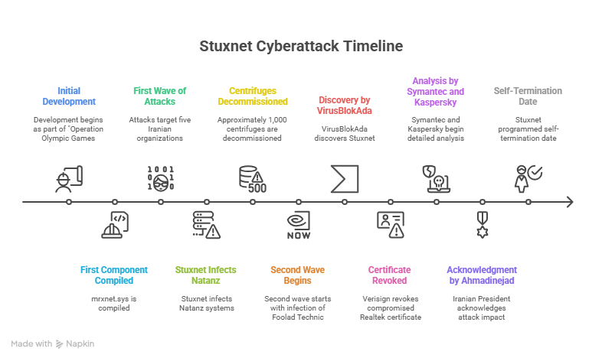

2. Technical Mechanism: The MITM Architecture
2.1 Multi-Layer Attack Strategy
Stuxnet implemented a sophisticated three-tier MITM attack targeting Windows systems, Siemens industrial software, and programmable logic controllers (PLCs).

Layer 1: Windows Exploitation
- Four Zero-Day Vulnerabilities: Unprecedented use of multiple unknown exploits
- LNK/PIF Vulnerability: Automatic execution when USB contents viewed
- Print Spooler Exploit: Network propagation through shared printing services
- Stolen Certificates: JMicron and Realtek signatures for rootkit installation

Layer 2: SCADA Software Infiltration
Stuxnet specifically targeted Siemens SIMATIC WinCC and Step7 software:
- Hard-coded Database Credentials: Exploited default SQL Server passwords
- Project File Infection: Injected malicious code into Step7 project files
- Library Replacement: Substituted legitimate s7otbxdx.dll with malicious version

Layer 3: PLC Manipulation and MITM Implementation
The core MITM functionality occurred at the PLC level:
Original Communication Path:
HMI ↔ s7otbxdx.dll ↔ Siemens PLC ↔ Physical Equipment
Stuxnet Modified Path:
HMI ↔ Malicious s7otbxdx.dll ↔ s7otbxsx.dll (renamed original) ↔ PLC ↔ Equipment

Key MITM Techniques:
1. DLL Hijacking: Renamed original communication library to s7otbxsx.dll
2. Function Interception: 16 critical API calls intercepted and modified
3. Data Manipulation: Altered commands to PLCs while preserving legitimate responses
4. Traffic Replay: Fed pre-recorded "normal" data to operators during attacks

2.2 Precision Targeting Mechanism
Stuxnet's MITM attack was extraordinarily selective:
- Hardware Fingerprinting: Required specific Siemens S7-315/S7-417 PLCs
- Frequency Range Detection: Monitored for 807-1,210 Hz motor operation
- Vendor-Specific Components: Targeted Vacon (Finland) and Fararo Paya (Iran) drives
- Cascade Configuration: Required 984 centrifuges arranged in specific patterns

2.3 Attack Execution Sequences
Sequence A (S7-315 Attack):
1. Reconnaissance Phase: 26-30 day observation period
2. Frequency Manipulation:
- Increase to 1,410 Hz for 15 minutes
- Reduce to 2 Hz for 50 minutes
- Return to normal 1,064 Hz
3. Concealment: Replay recorded normal data to HMI systems[134]
Sequence B (S7-417 Attack):
- Man-in-the-Middle on I/O: Intercepted signals between controller and physical hardware
- Process Image Falsification: Provided fake sensor data to legitimate control programs
- Gradual Degradation: Subtle pressure and valve manipulations over time

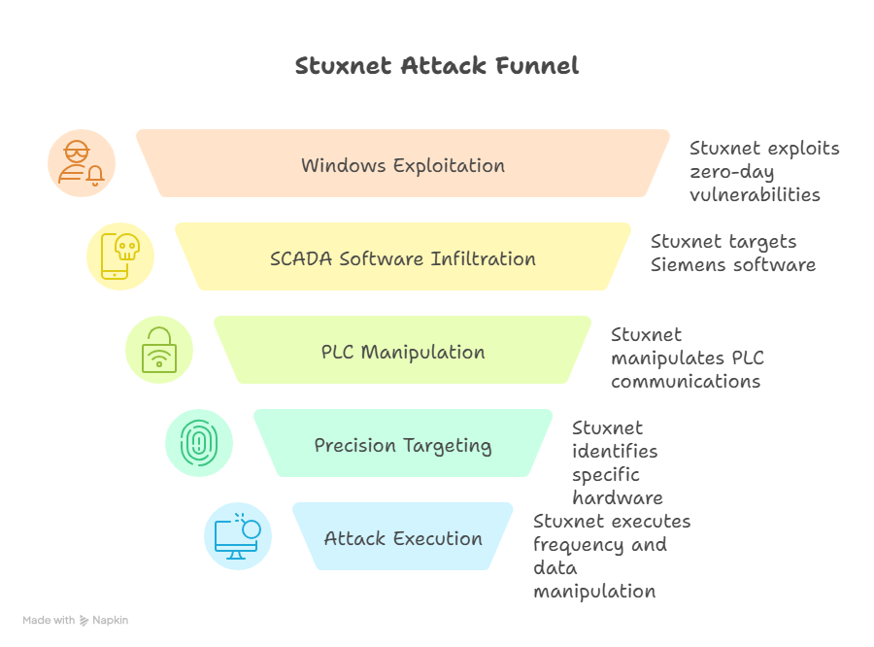

3. Impact Assessment
3.1 Physical Infrastructure Damage
- Centrifuge Destruction: Approximately 1,000 IR-1 centrifuges damaged/replaced
- Operational Capacity: 30% reduction in centrifuge performance reported
- Enrichment Delays: Significant setback to Iran's nuclear program timeline
- Equipment Costs: Estimated millions in replacement and repair expenses

3.2 Global Security Implications
- Proliferation: 200,000+ computers infected worldwide
- Infrastructure Vulnerability: Exposed critical weaknesses in industrial systems
- Cyber Warfare Precedent: First documented cyberweapon causing physical destruction

3.3 Legal and Diplomatic Consequences
- International Law Questions: Challenged existing frameworks for cyber conflict
- Attribution Complexity: Difficult to prove state responsibility definitively
- Deterrence Implications: Demonstrated nation-state cyber capabilities

3.4 Economic and Industrial Impact
- Security Investment: Massive increases in ICS security spending globally
- Operational Disruption: Widespread concern about industrial system vulnerabilities
- Supply Chain Trust: Reduced confidence in complex technology systems
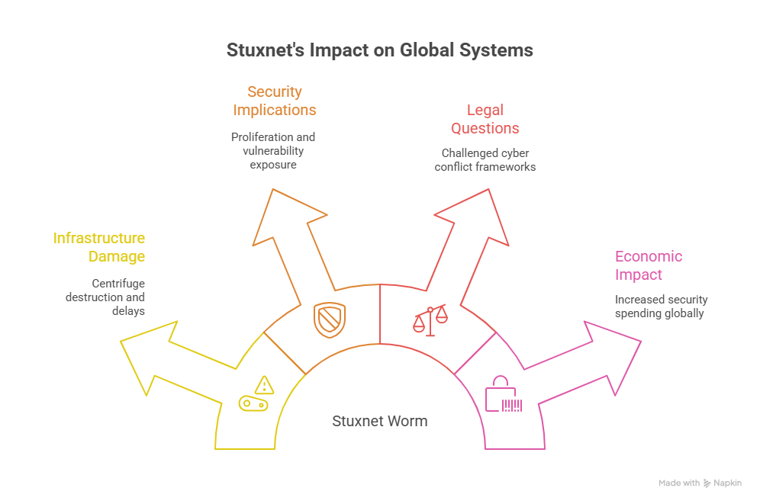

4. Detection and Response
4.1 Initial Discovery Process
The sophisticated MITM attack remained undetected for approximately three years:
Detection Timeline:
- 2010 (Early): IAEA inspectors noted unusual centrifuge failure rates
- June 17, 2010: VirusBlokAda identified suspicious files on Iranian systems
- July-September 2010: Security firms began reverse engineering
Detection Challenges:
- Rootkit Concealment: Kernel-level hiding prevented standard detection
- Targeted Nature: Dormant on non-target systems, avoiding attention
- Certificate Authenticity: Legitimate signatures bypassed security software

4.2 Industry Response and Mitigation
Immediate Actions (2010-2011):
- Microsoft Patches: All four zero-day vulnerabilities patched by February 2011
- Certificate Revocation: Compromised Realtek and JMicron certificates revoked
- Siemens Advisories: Detection and removal tools released

ICS-CERT Recommendations:
1. Network Segmentation: Isolate control systems from corporate networks
2. USB Controls: Restrict removable media usage in operational environments
3. Default Credential Changes: Eliminate hard-coded passwords
4. Regular Updates: Implement patch management for industrial systems
5. Access Controls: Strengthen authentication and authorization mechanisms

Long-term Industry Changes:
- Security Standards: Enhanced IEC 62443 industrial security frameworks
- Monitoring Systems: Improved anomaly detection for industrial networks
- Incident Response: Specialized ICS incident response capabilities

4.3 Technical Countermeasures Developed
Cryptographic Solutions:
- Message Authentication: Cryptographic validation of PLC commands
- Key Diversification: Randomized authentication keys for different message classes
- Impact-Aware Defense: Higher security for high-impact control commands

Behavioral Detection:
- Physics-Based Monitoring: Detection based on physical process deviations
- Baseline Establishment: Learning normal equipment "heartbeats"
- Real-time Correlation: Matching network commands with actual equipment behavior

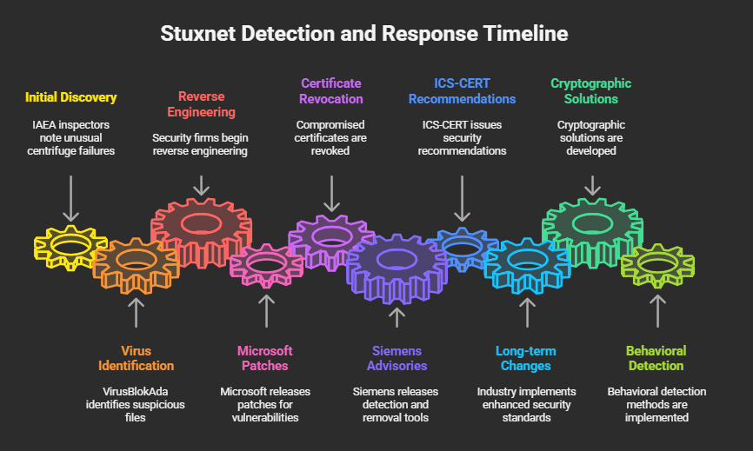

5. Lessons Learned and Defense Recommendations
5.1 Strategic Lessons
Air-Gap Limitations: Physical isolation insufficient against determined attackers
- Traditional network security perimeters easily bypassed
- Supply chain and insider access vectors remain viable
- Multi-vector attacks can traverse supposed security boundaries

Precision vs. Proliferation Trade-off: Stuxnet's wide spread led to its discovery
- Highly targeted attacks can remain hidden longer
- Broad propagation capabilities increase detection risk
- Balance required between reach and stealth

5.2 Technical Defense Recommendations
5.2.1 Network Architecture
- Defense in Depth: Multiple security layers with different detection mechanisms
- Network Segmentation: Strict isolation between IT and OT environments
- Microsegmentation: Granular control over inter-device communications
- Monitoring Zones: Comprehensive visibility into all network traffic

5.2.2 Access Controls
- Zero Trust Architecture: Verify every access request regardless of location
- Multi-Factor Authentication: Strong identity verification for all users
- Privileged Access Management: Strict controls over administrative functions
- Regular Access Reviews: Periodic validation of user permissions

5.2.3 Monitoring and Detection
- Behavioral Analytics: ML-based detection of abnormal system behavior
- Process Physics Monitoring: Hardware-level observation of industrial processes
- Cryptographic Integrity: Digital signatures for all control commands
- Real-time Correlation: Cross-validation between cyber and physical domains

5.2.4 Incident Response
- ICS-Specific Playbooks: Specialized response procedures for industrial environments
- Cross-Domain Teams: Integration of IT, OT, and business personnel
- Forensic Capabilities: Specialized tools for industrial system investigation
- Recovery Procedures: Tested methods for system restoration

5.3 Regulatory and Standards Framework
Current Standards:
- NIST SP 800-82: Guide to Industrial Control Systems Security
- IEC 62443: International standard for ICS security
- ISO 27001/27002: Information security management frameworks

Recommended Enhancements:
- Mandatory Reporting: Required disclosure of ICS security incidents
- Certification Programs: Validated security for critical industrial components
- Supply Chain Security: Verification requirements for industrial equipment
- International Cooperation: Shared threat intelligence and response coordination

5.4 Organizational Preparedness
Executive Leadership:
- Risk Awareness: Understanding of cyber-physical attack vectors
- Investment Priorities: Adequate funding for ICS security programs
- Incident Planning: Board-level oversight of crisis response procedures
Technical Teams:
- Cross-Training: IT security staff education in OT environments
- Simulation Exercises: Regular practice with ICS attack scenarios
- Vendor Coordination: Established relationships with industrial equipment suppliers

6. Conclusion
The Stuxnet attack fundamentally changed the cybersecurity landscape by demonstrating that software-based attacks could cause significant physical damage to critical infrastructure. Its sophisticated man-in-the-middle techniques—intercepting communications between operators and industrial systems while presenting falsified data—established a new paradigm for cyber warfare.
Fifteen years after its discovery, many of the vulnerabilities that enabled Stuxnet remain present in industrial environments worldwide. The core lesson is that effective defense requires understanding the intersection of cyber and physical domains, implementing defense-in-depth strategies, and maintaining continuous vigilance against evolving attack techniques.
As industrial systems become increasingly connected and complex, the Stuxnet precedent serves as both a warning and a guide for developing resilient critical infrastructure. The next generation of cyber-physical attacks will likely build upon Stuxnet's innovations, making robust defensive measures more critical than ever.

Bibliography
1. Langner, Ralph. "Our Stuxnet Timeline." Langner Group, December 2010. Available: https://www.langner.com/2010/12/our-stuxnet-timeline/
2. Falliere, Nicolas, Liam O Murchu, and Eric Chien. "W32.Stuxnet Dossier." Symantec Security Response, February 2011.
3. Kaspersky Lab. "Stuxnet Definition & Explanation." Kaspersky Resource Center, September 2017.
4. Albright, David. "Did Stuxnet Take Out 1000 Centrifuges at the Natanz Enrichment Plant?" Institute for Science and International Security, December 2010.
5. Zetter, Kim. "An Unprecedented Look at Stuxnet, the World's First Digital Weapon." WIRED, November 2014.
6. CCDCOE. "Stuxnet Facts Report." Cooperative Cyber Defence Centre of Excellence, 2012.
7. Trautman, Lawrence J. "Industrial Cyber Vulnerabilities: Lessons from Stuxnet." University of Miami Law Review, Vol. 72, 2018.
8. Wikipedia Contributors. "Stuxnet." Wikipedia, The Free Encyclopedia, 2010-2025.
9. Clark, Andrew, et al. "An Impact-Aware Defense against Stuxnet." University of Illinois Science of Security Lablet, 2014.
10. ENISA. "Stuxnet Analysis - European Union Agency for Cybersecurity." ENISA, 2010.

